Assignment:- 8
ALP Program

Write 8086 ALP to find and count negative and positive number from signed array stored in memory and display magnitude of negative numbers.

section .data
arr db 10, -5, -12, 7, -3, 8, 0, -9, 4, -6
len equ 10
pos_count db 0
neg_count db 0
msg_pos db "Positive count: ", 0
msg_neg db "Negative count: ", 0
newline db 10

section .bss
buffer resb 4 ; for integer to string conversion

section .text
global _start

_start:
mov rcx, len
lea rsi, [rel arr]

loop_start:
mov al, [rsi]
cmp al, 0
jl negative
inc byte [pos_count]
jmp next

negative:
inc byte [neg_count]

next:
inc rsi
loop loop_start

; print "Positive count: "
mov rsi, msg_pos
call print_string
movzx rax, byte [pos_count]
call print_number

; newline
mov rsi, newline
call print_string

; print "Negative count: "
mov rsi, msg_neg
call print_string
movzx rax, byte [neg_count]
call print_number

; newline
mov rsi, newline
call print_string

; exit
mov rax, 60
xor rdi, rdi
syscall

; ---------------------
; print_string (rsi = address)
print_string:
push rax
push rdi
push rdx
mov rax, 1
mov rdi, 1
mov rdx, 0
count_loop:
cmp byte [rsi+rdx], 0
je print_it
inc rdx
jmp count_loop
print_it:
syscall
pop rdx
pop rdi
pop rax
ret

; ---------------------
; print_number (rax = number)
print_number:
mov rcx, buffer+3
mov byte [rcx], 0
convert_loop:
dec rcx
xor rdx, rdx
mov rbx, 10
div rbx
add dl, '0'
mov [rcx], dl
test rax, rax
jnz convert_loop
mov rsi, rcx
call print_string
ret

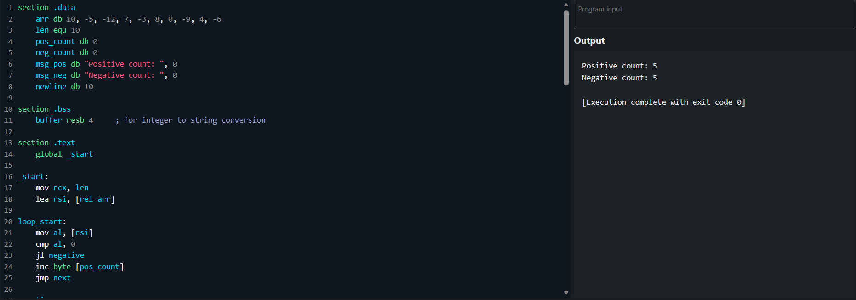
Output:

